**Unit 1: Introduction to Cyber Security**

* Cyber security is the application of technologies, processes and controls to protect systems, networks, programs, devices and data from cyber-attacks. It aims to reduce the risk of cyber-attacks and protect against the unauthorized exploitation of systems, networks and technologies.
* In today's world, cybersecurity is very important because of some security threats and cyber-attacks. For data protection, many companies develop software. This software protects the data. Cybersecurity is important because not only does it helps to secure information but also our system from virus attack.
* Confidentiality, integrity and availability, also known as the CIA triad, is a model designed to guide policies for information security within an organization. The model is also sometimes referred to as the AIC triad (availability, integrity and confidentiality) to avoid confusion with the Central Intelligence Agency.
* 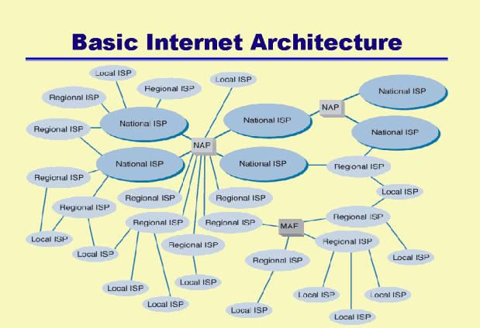
* 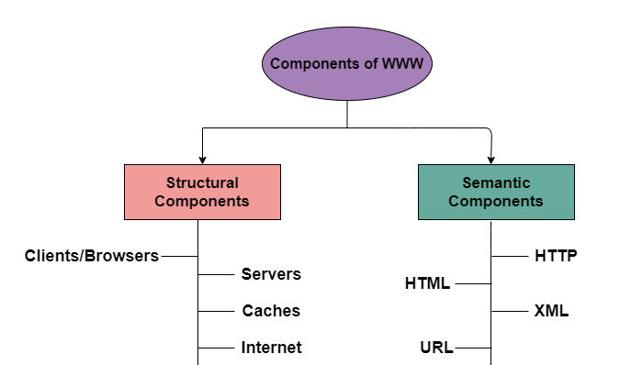
* Types of security attacks and vulnerabilities in systems:

Network Vulnerabilities

Operating System Vulnerabilities

Human Vulnerabilities

Process Vulnerabilities

* Types of networks:

